Errors coming before automation

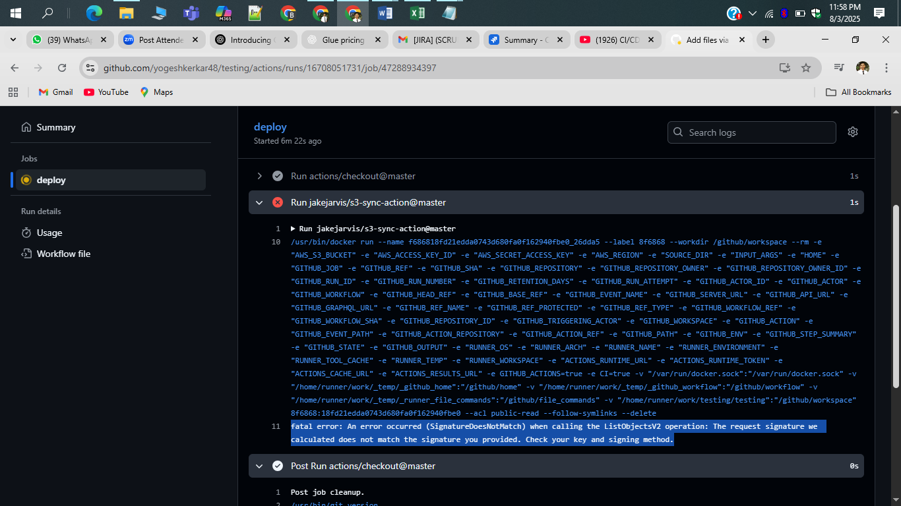

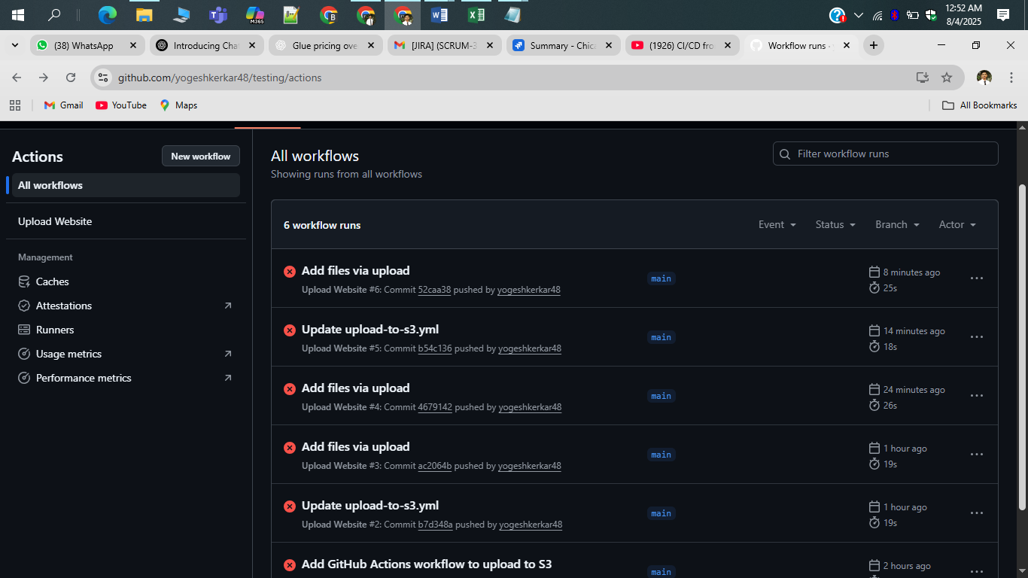

Testing repository

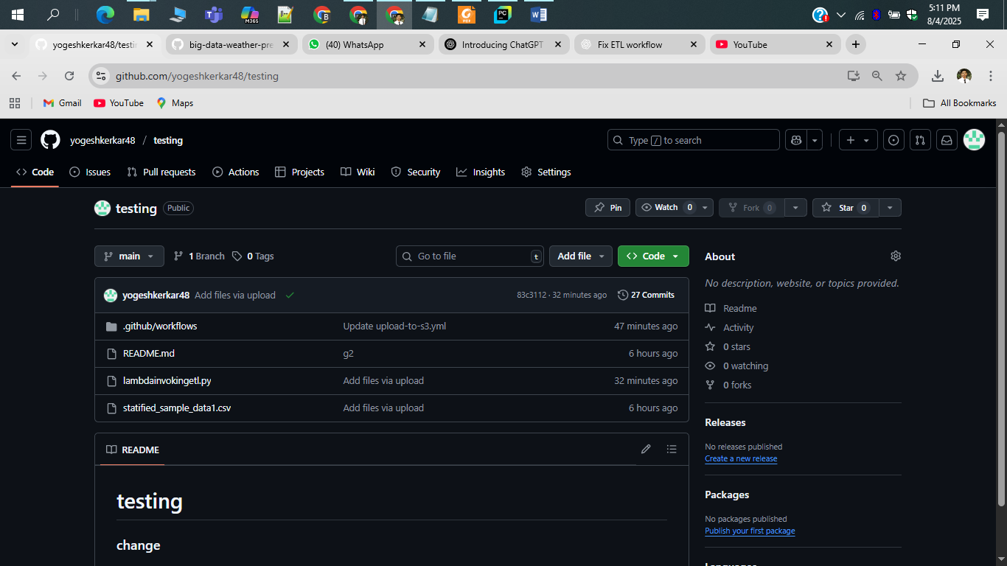

Whole script for automation

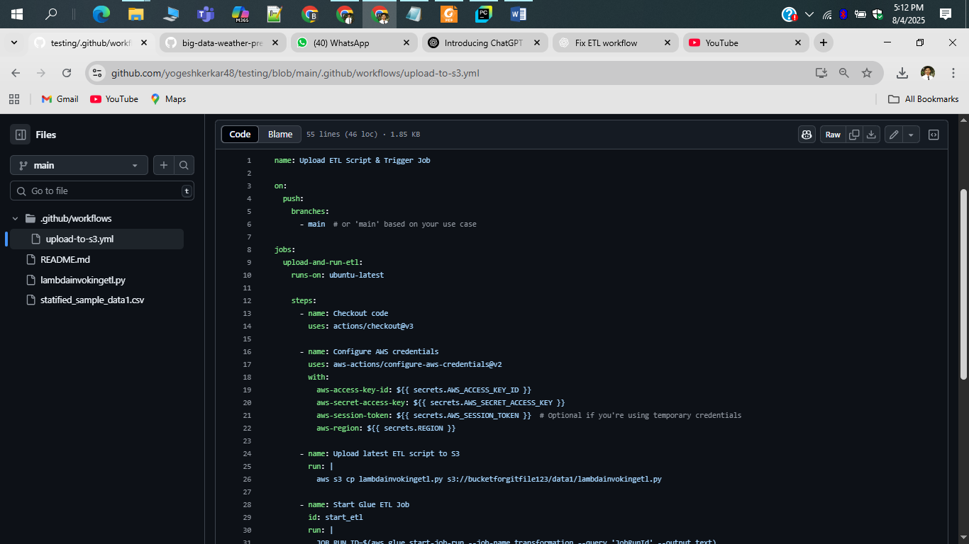

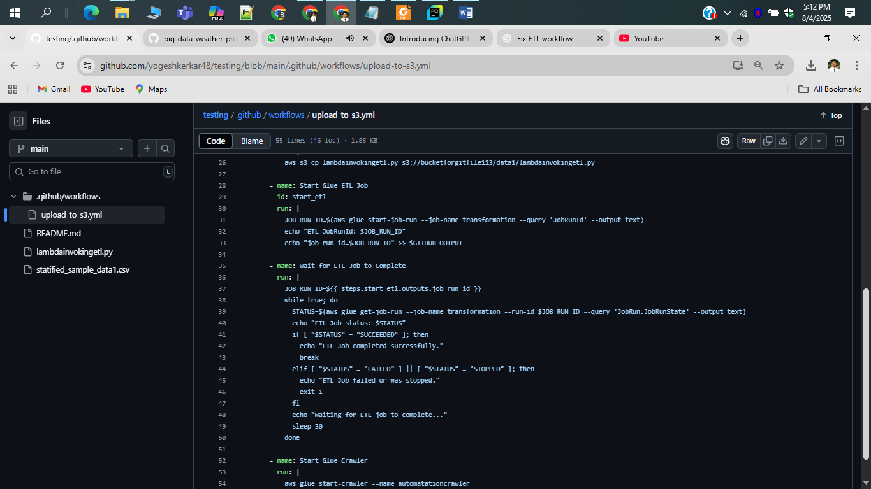

Actions in github

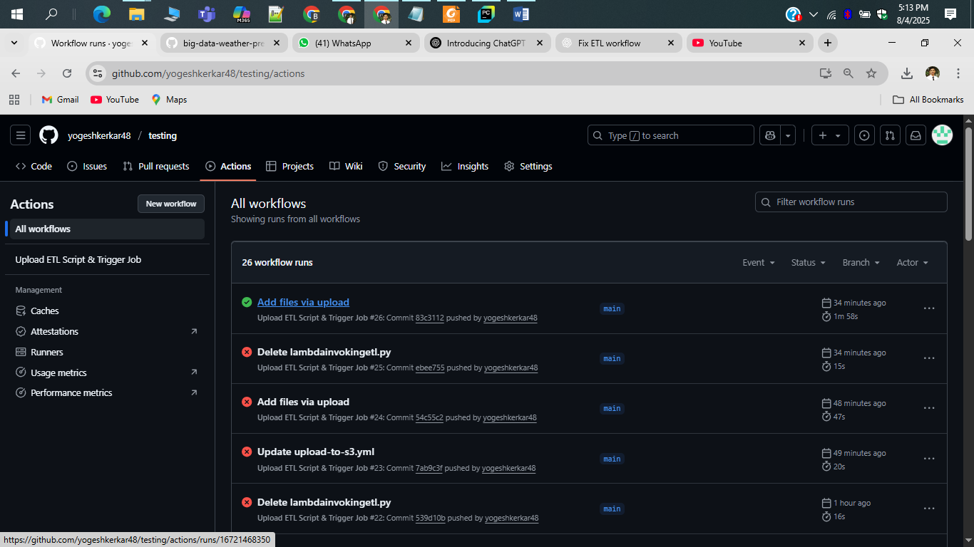

Done automation

1ST-SCRIPT file will go into s3 bucket

2nd-ETL glue job extract that script from s3 and run

3rd –on that that crawler will run

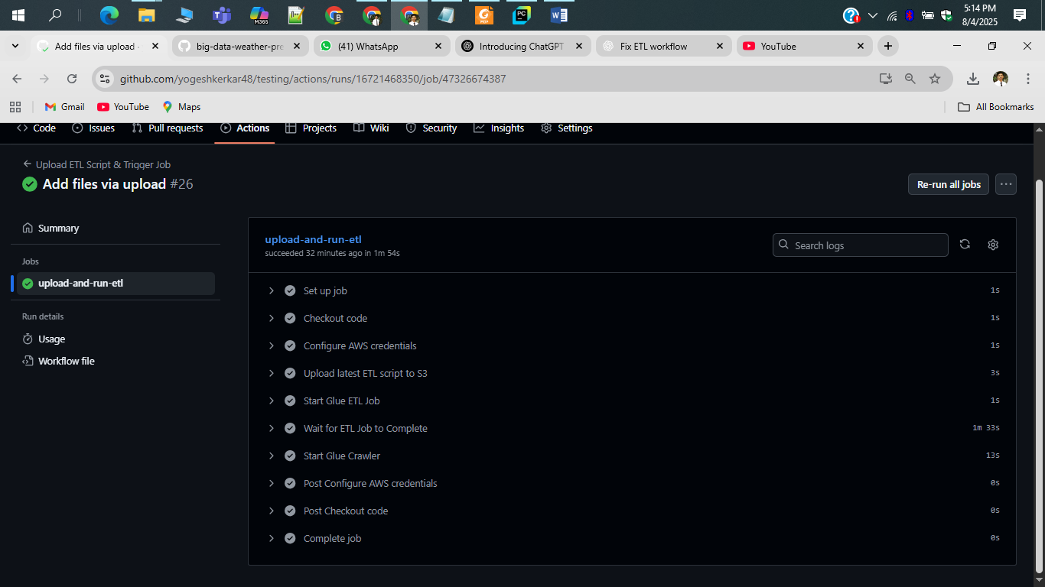

FILE COMES INTO S3 BUCKET

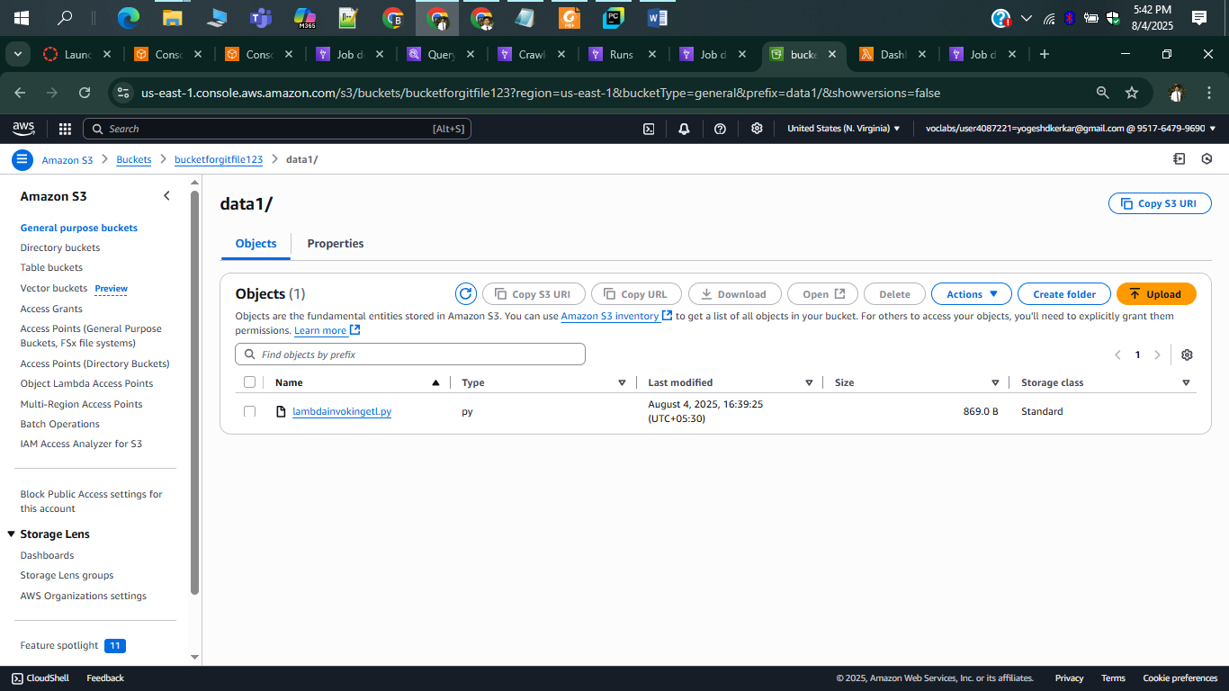

ETL JOB RUNS SUCCESFULLY

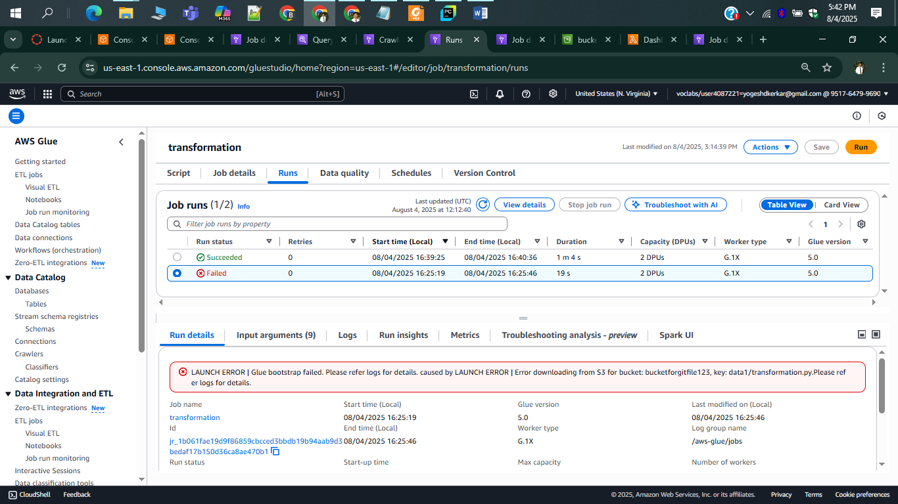

TRASFORM DATA COMES INTO S3 BUCKET

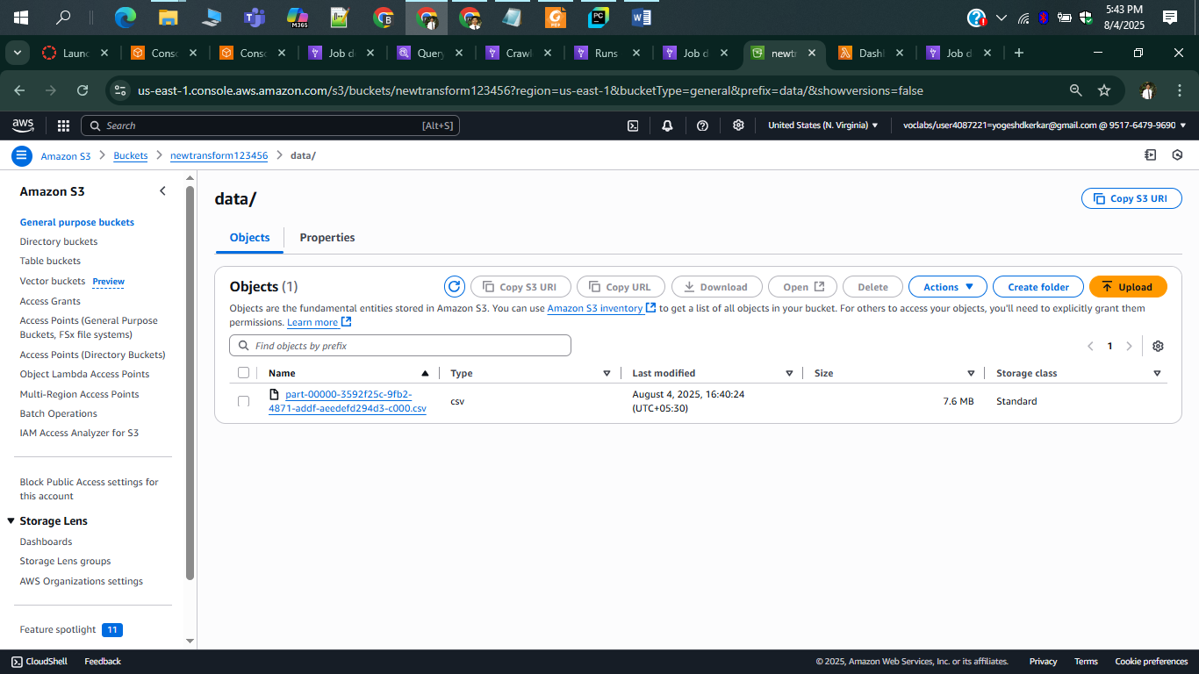

CRWLERS RUNS AUTOMATICALLY

